22.37: a) 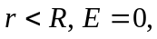 since no charge is enclosed.
b) 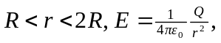 since charge enclosed is 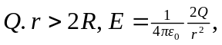 since charge enclosed is 2Q.

